UI/UX improvement suggestions

- “Welcome” text written in the left alignment. If the “Welcome” text is written in the middle, then it will look good.
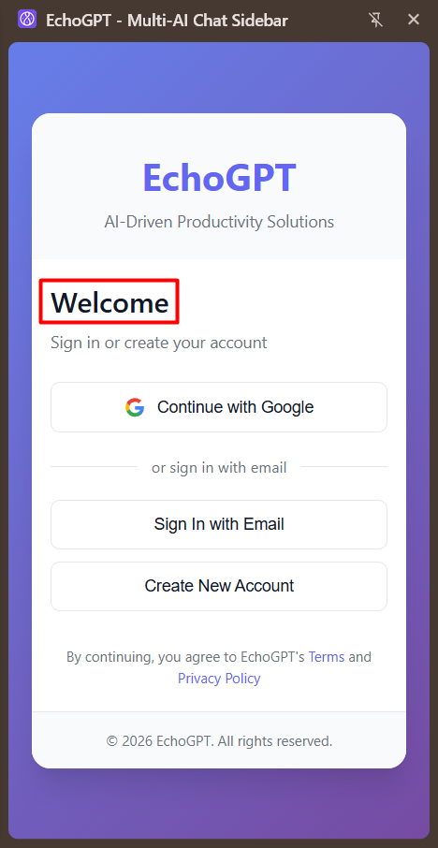 → 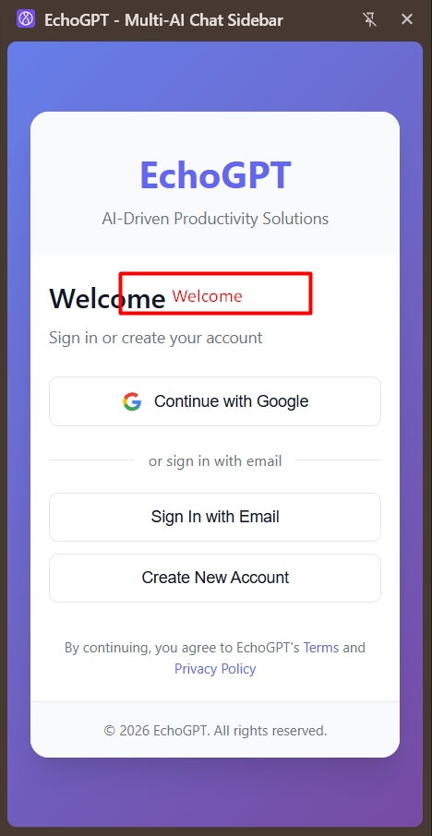

- “Sign in or create your account” text written in the left alignment. If the “Sign in or create your account” text is written in the middle, then it will look good.
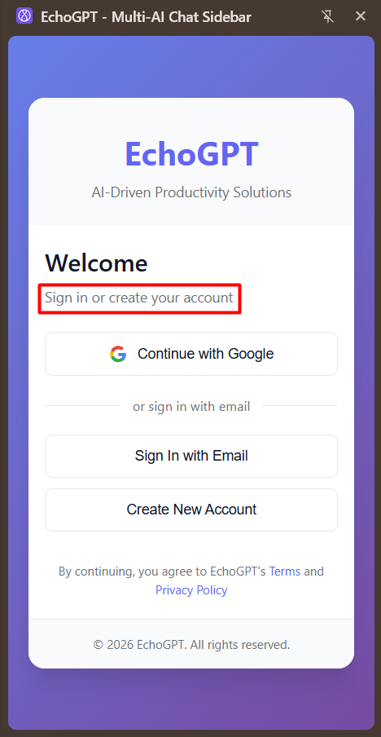

- In the welcome page, if it is written “Sign In” then “Sign In with Email” and then “Continue with Google”, after that “Don’t have an account? Sign Up” it will look better.
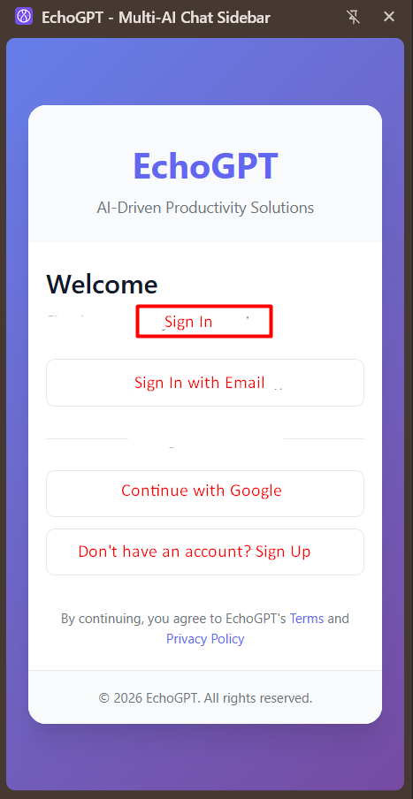
- At the bottom it is written “By continuing, you agree to EchoGPT's Terms and Privacy Policy”, if it is written “Terms & Conditions” it will sound good.
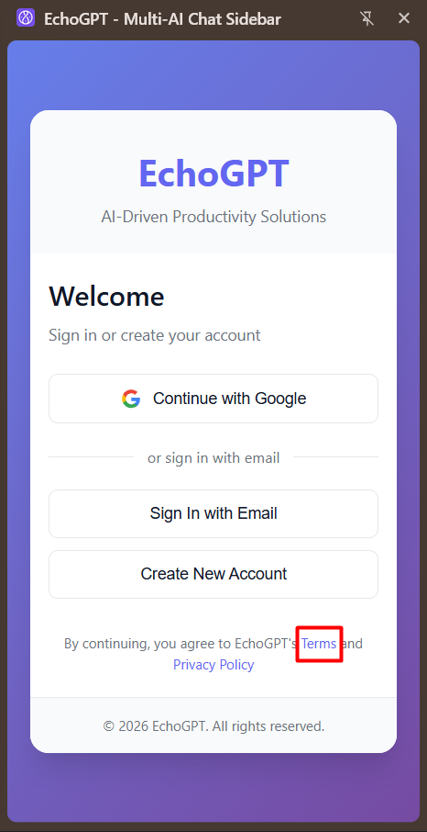
- After successful login, “Hi, good afternoon” message is not showing properly in the small sidebar. When the user increases the window sidebar, it shows properly. So it’s better to fix the UI.
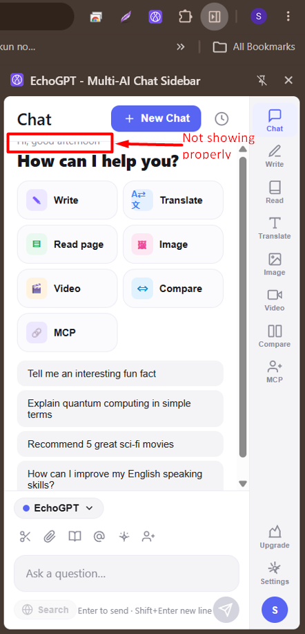

- Chrome extension (EchoGPT) & Mobile app (Echochat) both are the same platform. It would be better if you keep the name and logo similar.
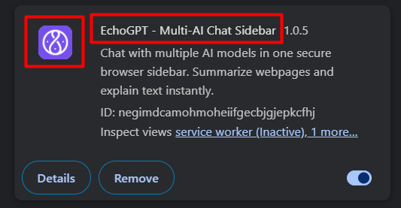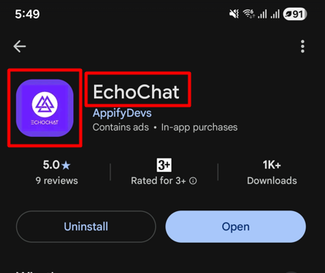

- After deleting history, back to the dashboard and see there is a gap showing and all the options are not visible within the dashboard.
Video URL: https://drive.google.com/file/d/1jG5jZz65vx6ZHAbc8U1oGgM3Ak2PDUYa/view?usp=drive_link

- If you click the settings and account icon in the sidebar, it shows only one option: SignOut. Then what’s the point of these two different options!
VIdeo URL: https://drive.google.com/file/d/1XXenGofmwXMKNc3PRgrpk2BfFxmNcmQO/view?usp=drive_link

- In the Read section, after uploading a file in the “READ A FILE” section, there should be an Send/Read/Go button, then it will be better.
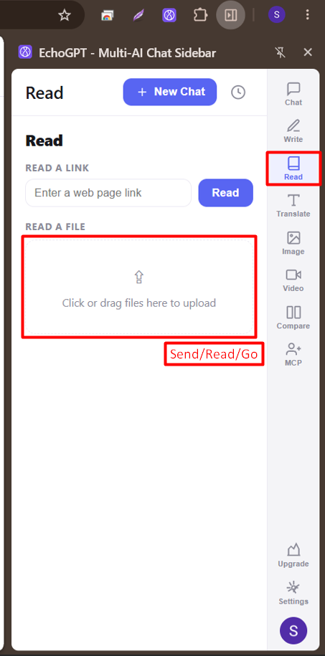
- In the EchoGPT sidebar, if there is an option called Color theme to the dark/light mode in the settings, it would be better.
- After deleting any chat it shows a chat delete pop-up. This pop-up shows in front of the cross sign. It’s better if the pop-up shows in the middle of the window.
Video URL: https://drive.google.com/file/d/1yKW8gTZQcBhKbFrIDeH14qbLjxl5dx6p/view?usp=drive_link

- In the Chrome extension, if there is a back navigation on the EchoGPT sidebar, it will be better.

